Deployment

* Deployment environment - Azure (Web App)
* How we did it
  + As a student, you get $100 in Azure credit. If you don't keep your server running for long periods of time and only use it during testing, deployment, and final presentation $100 should easily cover what is needed in this project.
  + Steps to build an azure web app instance
    1. Go to the following website <https://azure.microsoft.com/en-us/free/students/> here you can sign up for an azure account for free with **no credit card required.**
    2. **Step 1 -** Once you have created an account and logged in you will be brought to the azure dashboard click on create new (plus button)

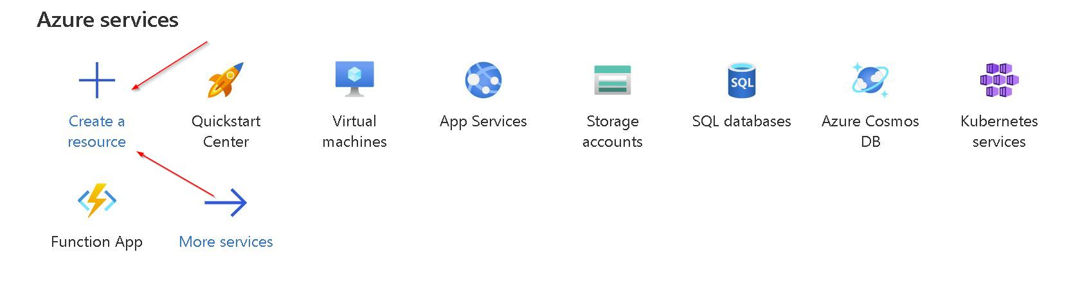

* + 1. **Step 2 -** Next clock on create under Web App

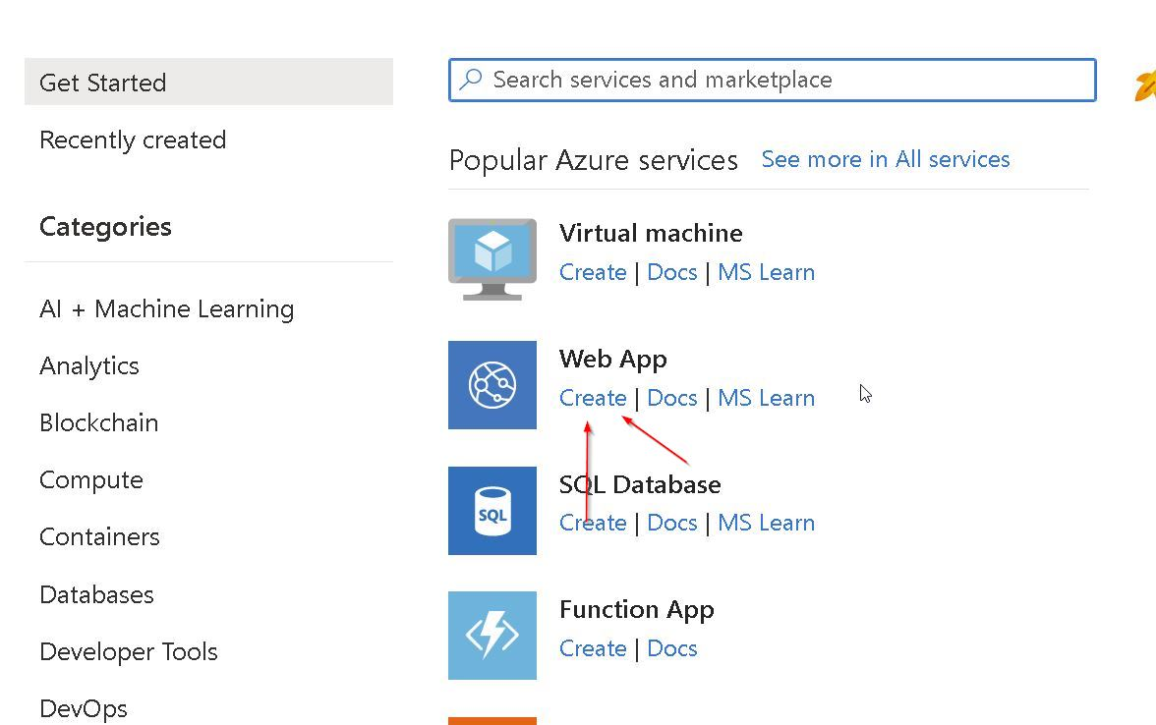

* + 1. **Step 3 -** After that you will be in the page where you can name your server (if the name has been used you cannot use it), also pick the runtime stack

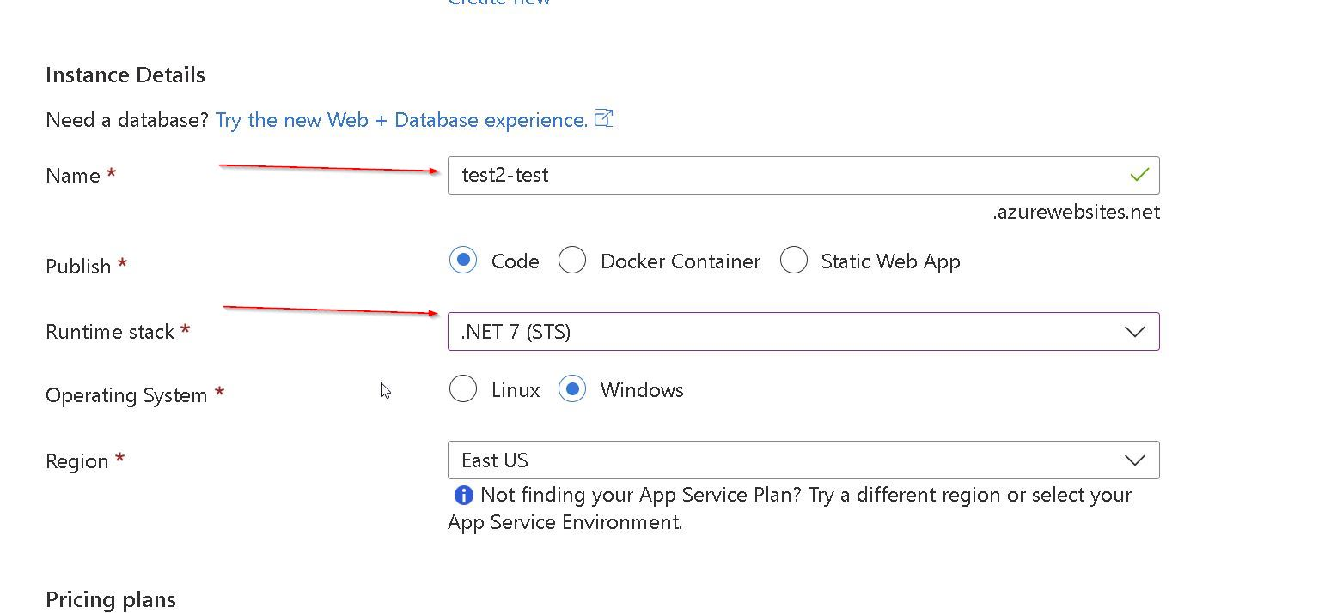

* + 1. **Step 4 -** Next review your windows plan (should be auto filled), and select review and create.

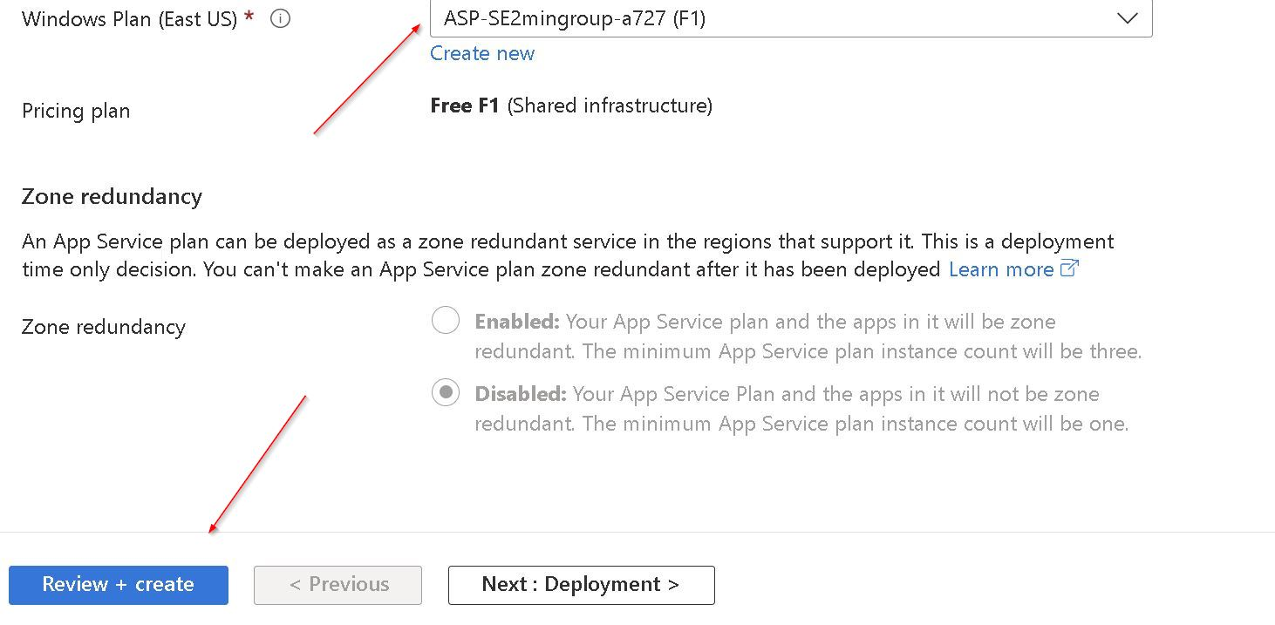

* + 1. **Step 5 -** Review your instance and click create

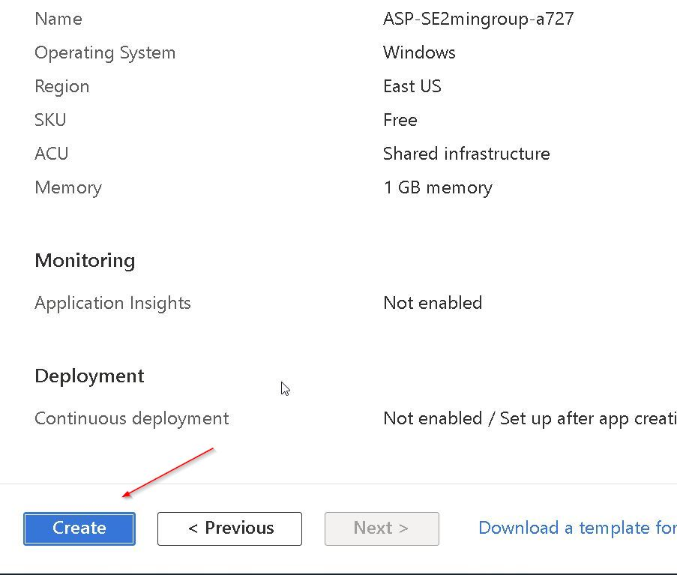

* + 1. **Step 6 -** At this point, you will wait for the server to build and deploy and once done click go to resource

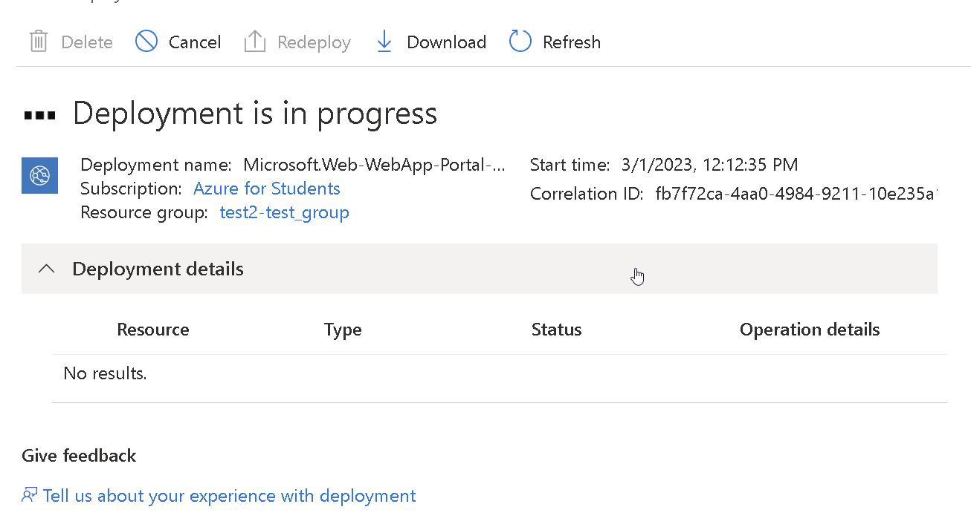

* + 1. **Step 7 -** From here you will see the dashboard for the instance you have created it will look like what I have pasted below

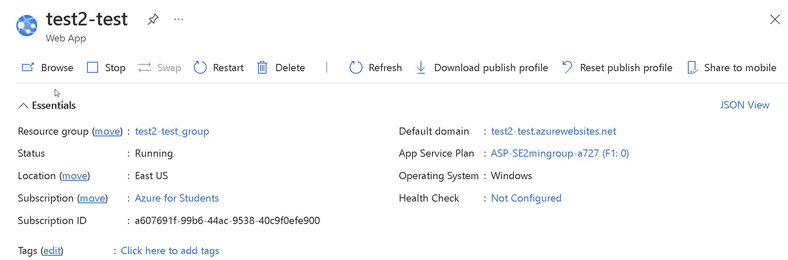

* + 1. **Step 8 -** At the top, you have the server name that you created and below that, you will see quick actions the most important of which is stop and start which just like it seems will stop and start your server



* + 1. **Step 9 -** Below that, you see the information about the server you created specifically its web address. You can copy this once you have successfully deployed and the server is on to test your build.

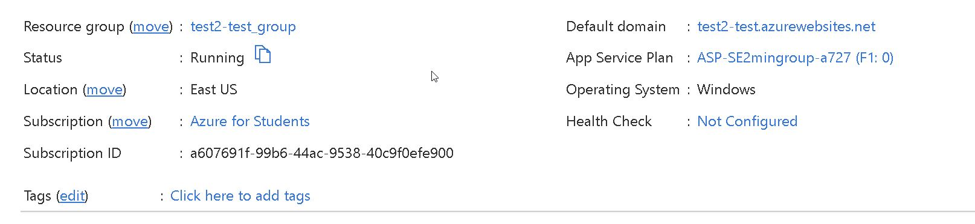

* + Steps to deploy to Azure from VS
    1. We used the ASP.NET core web app Template in visual studio to build the site
    2. First, you need to build your solution which will give you a blank website

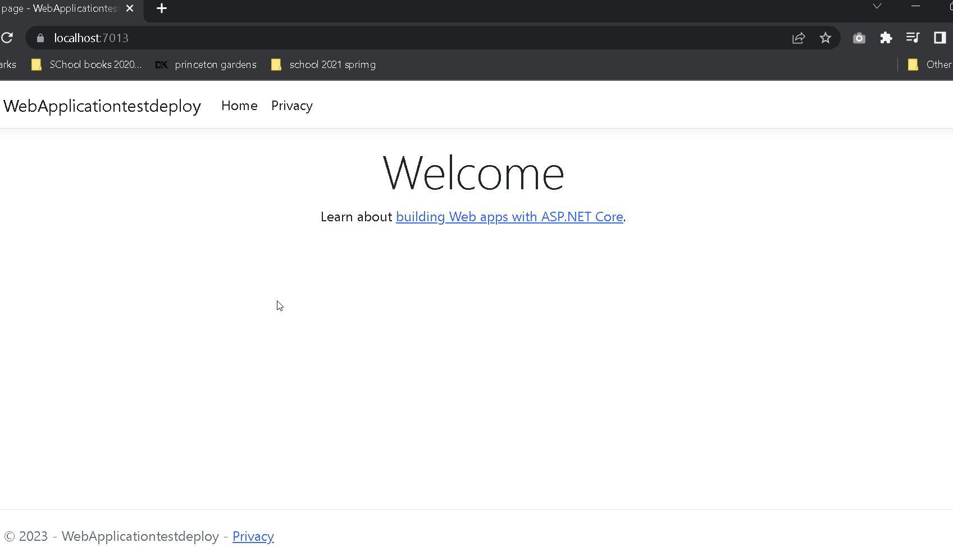

* + 1. Once your project has been built right click on the project and select publish

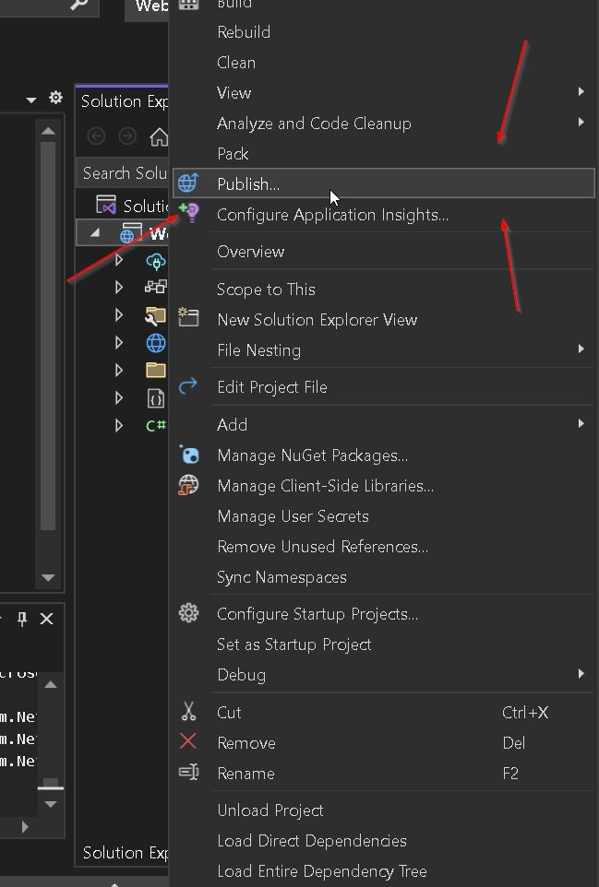

* + 1. The next screen will give the options of where you want to publish, in this case, we are using azure so click azure.

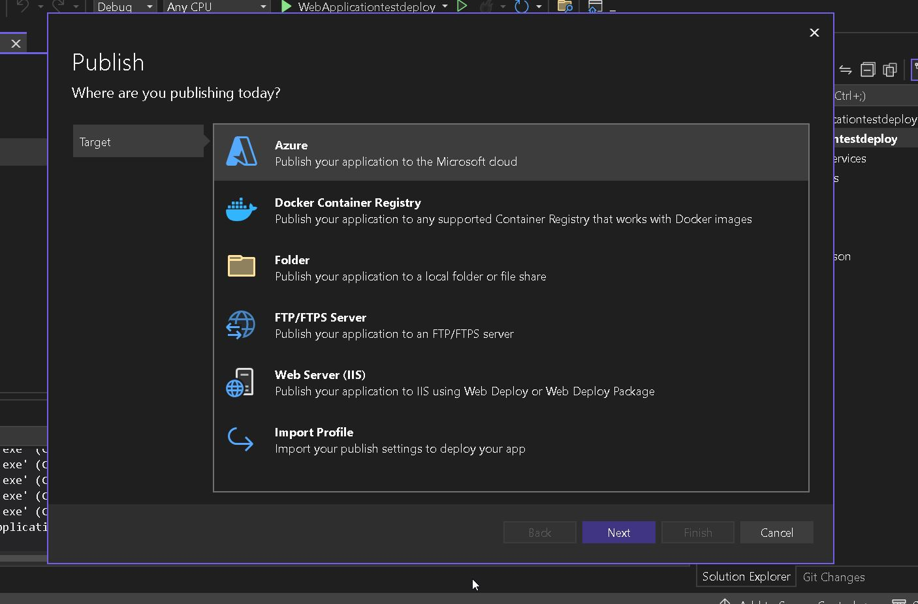

* + 1. Next, there are the different types of azure containers you can deploy to. In this case, we built a windows instance, but as you can see you have options, click windows

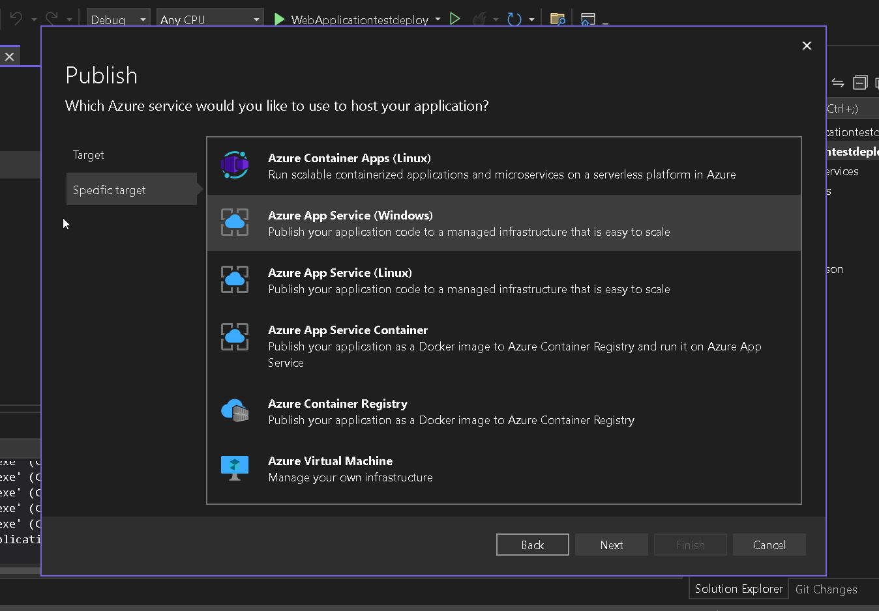

* + 1. After this, you will see all the groups and the server instances associated with each group select the server you want to deploy to.

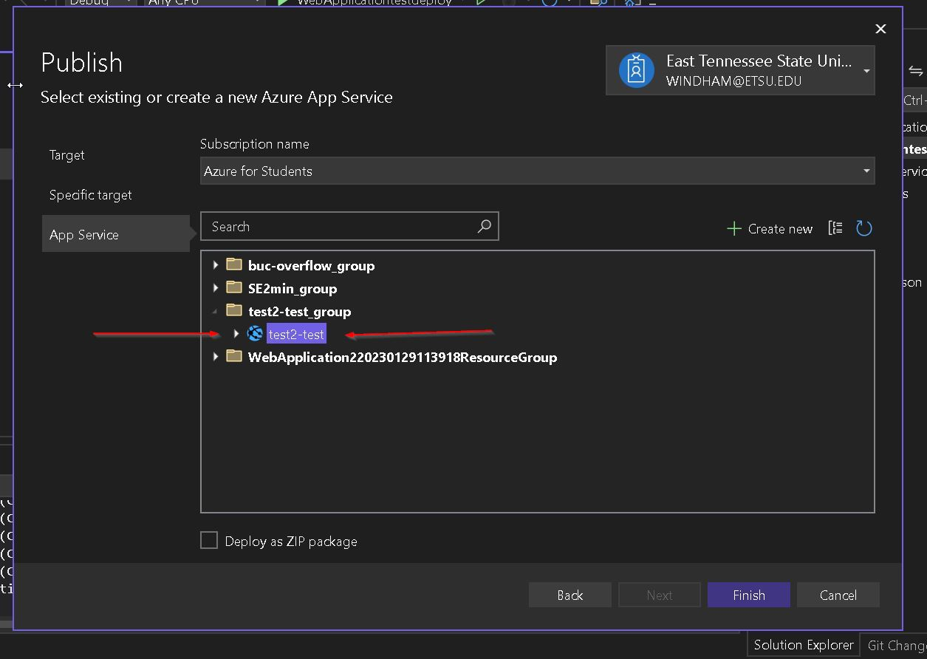

* + 1. Once you have successfully created a publish profile the following will show. Close out of this window

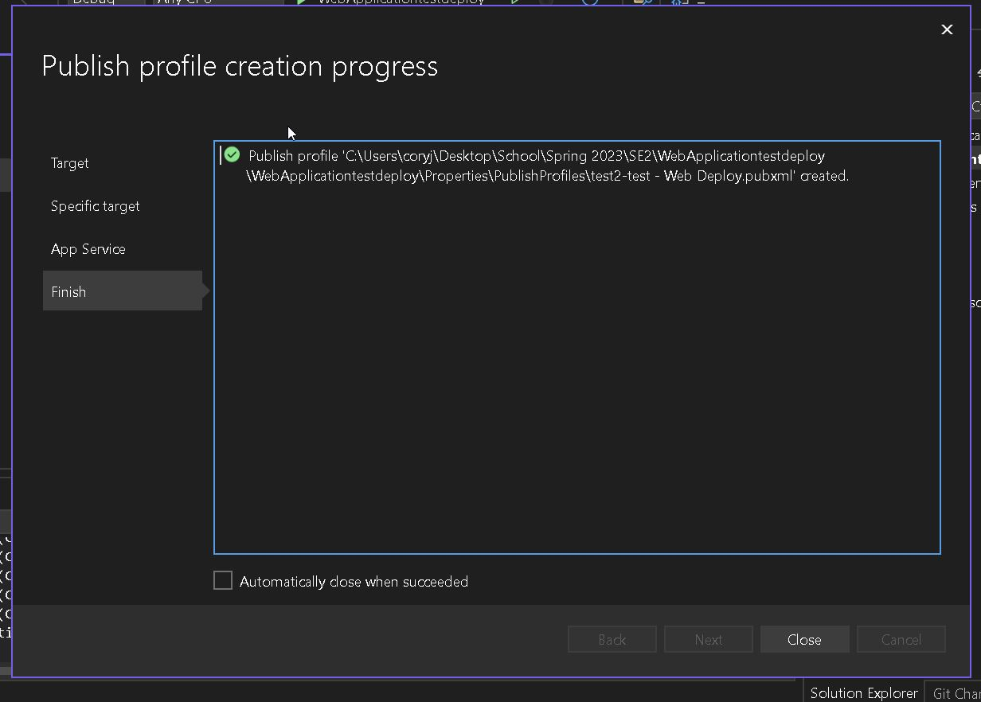

* + 1. At this point you are ready to publish click publish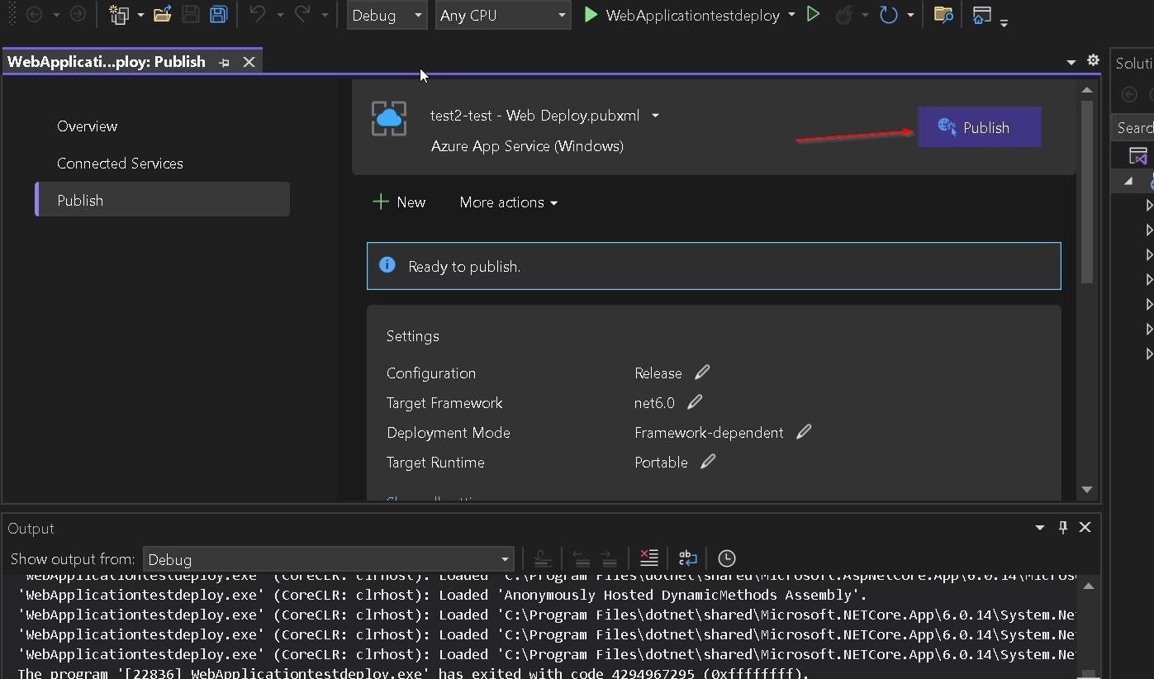
    2. Now, ensure your server is running and test the url provided on the server webpage

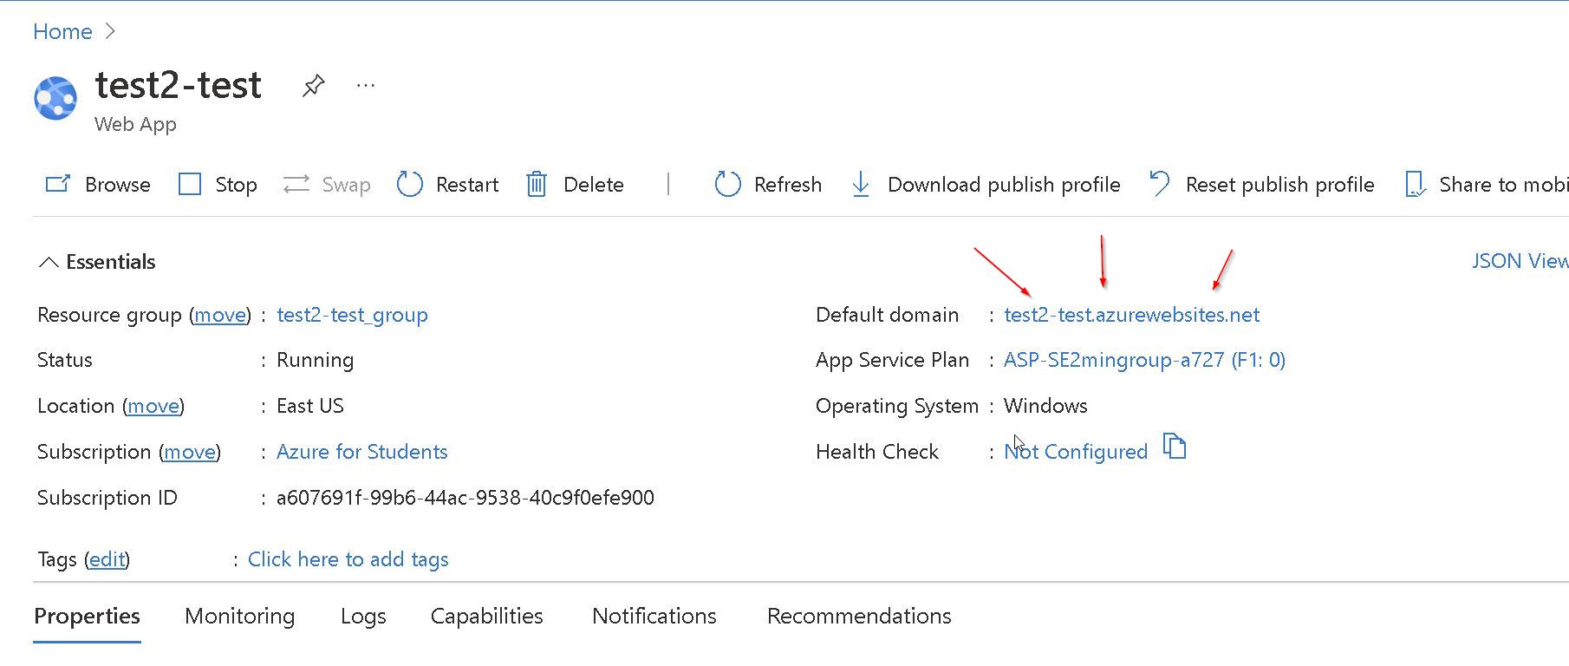

* What we didn't use and why.
  + We did not decide to use a server offered by ETSU due to the complexity required and the fact that we are a more minor team of 6.
    1. If you have someone on your team well versed in IT and deployment through IIS and windows servers then that might be an option.
  + We did not use AWS for this reason as well however there is a free tier of AWS that can be used with less than 750 hours of uptime a month. If you use one server to deploy it is possible to use this as an option with a windows or Linux server instance in AWS.
  + If you have a real IT wiz you can use an old computer and image it to a Linux or Windows server and host it that way, but that is over the heads of many students